Kubernetes (Manual deployment)
Bash script for Install microKs8
#!/bin/bash
echo "Starting MicroK8s installation..."
# Install microk8s using snap
sudo snap install microk8s --classic
# Add current user to microk8s group to manage microk8s without sudo
sudo usermod -a -G microk8s $USER
# Change ownership of kube config
sudo chown -f -R $USER ~/.kube
echo "MicroK8s installation complete. Please log out and log back in for the permission changes to take effect."

To make the alias permanent, add the above line to your shell configuration file, e.g., ~/.bashrc or ~/.bash_aliases:
echo "alias kubectl='microk8s kubectl'" >> ~/.bashrc
source ~/.bashrc
git clone https://github.com/ManojKRISHNAPPA/kubernetes-docs.git
or
Deploying the web application using kubernetes (manual deployment)
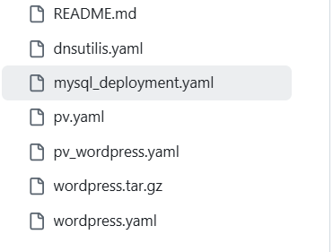
Mysql_deployment.yaml
File explanation
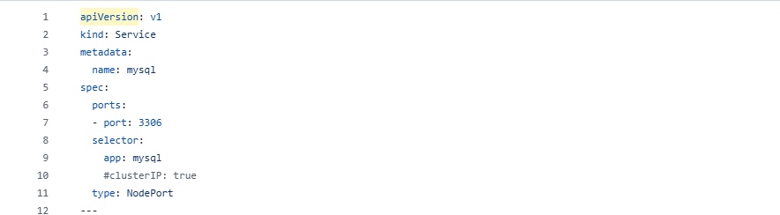
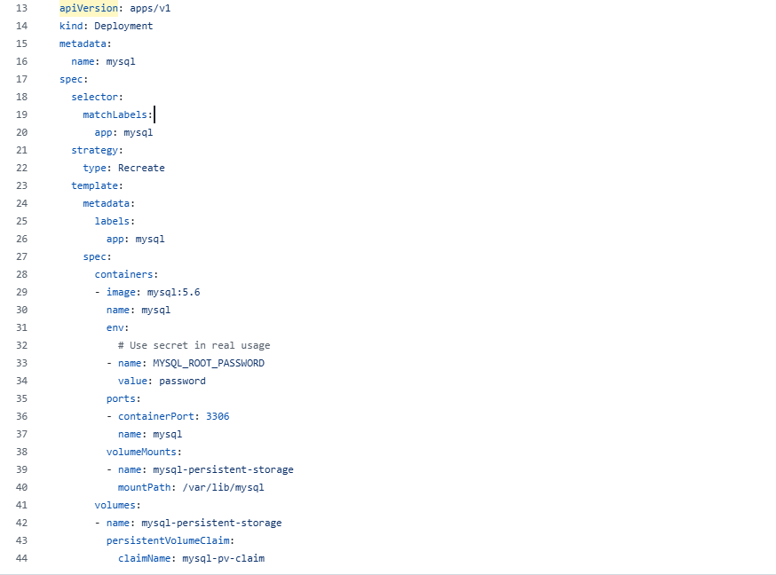
Here, explanation mysql_deployment.yaml file which contain both deployment and service.yaml
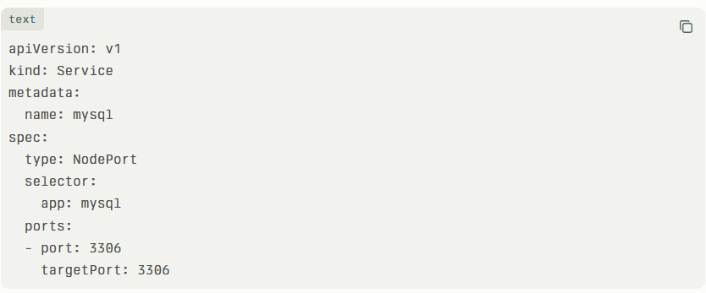
Service section:
The selector is used to identify a group of Pods by their labels (e.g., app: mysql). This lets the Service route traffic to the correct Pods. It does not assign an IP address or port to the Pods themselves.
type: NodePort exposes the Service outside the cluster by opening a specific port on every Node.
Every worker node has ip address, External requests sent to any Node’s IP address on the NodePort (a port between 30000 and 32767) are forwarded to the Service, which then sends the requests to the target Pods.
for single-instance databases, using NodePort without a Load Balancer is simpler and sufficient.
Kubernetes uses the NodePort range between 30000 and 32767 mainly to avoid conflicts with other system and reserved ports on the nodes.
When you use a NodePort service, Kubernetes assigns a stable port within this range to expose the service externally.
If a Pod (such as the database) restarts or crashes, Kubernetes may assign a new Pod IP, but the NodePort remains the same, ensuring the external port does not change.
This stability prevents connection issues caused by changing ports, making NodePort suitable when you need a consistent access point to your service.
So, NodePort helps keep the external port stable even if Pods restart or fail, while the underlying Pod IP addresses can change independently.
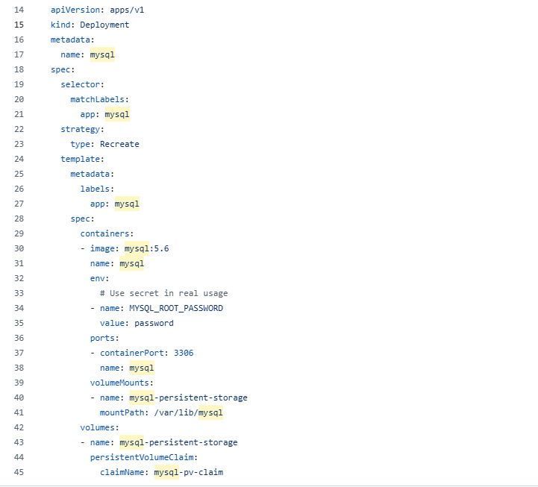
Above deployment contain:
- Here we are creating Database pod.
- Deployment
- Label = app:mysql
- Spec : we got to spec because till we know every things
Here, we pulling mysql:5.6 for pod which name is mysql
env:
# Use secret in real usage
- name: MYSQL_ROOT_PASSWORD
value: password

Here we set the password as password (value: password)
Environment variables (env) in Kubernetes are like small bits of information you give to a container to tell it how to behave. For example, they set things like passwords or addresses the app needs. This way, you don’t have to change the app's code to make it work in different situations.
In your MySQL example, MYSQL_ROOT_PASSWORD is an environment variable that sets the root password for the database when it starts. Using env keeps your app flexible and makes it easier to manage settings without changing the container image every time.
ports:
- containerPort: 3306
name: mysql
The containerPort: 3306 tells Kubernetes which port the MySQL container is using inside the Pod. It helps Kubernetes and related tools know where the app listens for traffic. Although it's mostly for clarity and documentation, it also helps link Services to the right port inside the
The name field under ports is not strictly required, but it is highly recommended. Naming ports helps make your configuration clearer and easier to manage,
Especially when:
You have multiple ports defined in the same container.
You create Services that refer to ports by name instead of port number.
You want easier debugging and better readability.
-------------------------------------------------------------------------------------------------------------------------------------------------------------------
volumeMounts:
- name: mysql-persistent-storage
mountPath: /var/lib/mysql
volumes:
- name: mysql-persistent-storage
persistentVolumeClaim:
claimName: mysql-pv-claim

- name: mysql-persistent-storage
The name in volumeMounts connects the mount point inside the container to the actual volume defined in the volumes section of the Pod.
In simple terms:
It tells Kubernetes which storage to attach inside the container.
The name in volumeMounts must match the name in volumes.
Without this matching name, Kubernetes won’t know what storage to mount or where.
So, the name is like a link that makes sure the right storage volume is attached to the right container path

----------------------------------------------------------------------------------------------------------------------------------------------------------------------------------
Note:
volumeMounts:
- name: mysql-persistent-storage
mountPath: /var/lib/mysql
Inside the container, there is a folder called /var/lib/mysql. This folder is linked to a storage volume named mysql-persistent-storage. Whatever data the container writes or reads from /var/lib/mysql is actually stored in that external volume. This way, the data stays safe and does not get lost when the container restarts.
In simple terms, it connects a folder inside the container to a persistent storage location outside the container, making sure important data like MySQL database files are kept safely.

volumes:
- name: mysql-persistent-storage
persistentVolumeClaim:
claimName: mysql-pv-claim
Imagine you created a PVC named mysql-pv-claim that requests 10Gi of storage. This claim gets bound to a 10Gi physical storage volume by Kubernetes. Now, the pod declares a volume named mysql-persistent-storage that uses this claim. This volume can then be mounted inside a container to persist MySQL data.
In simple terms, this setup tells Kubernetes: "Use the storage requested by the claim mysql-pv-claim for the volume mysql-persistent-storage in this pod." It ensures persistent data storage independent of container restarts.
In simple terms, this setup tells Kubernetes: "Use the storage requested by the claim mysql-pv-claim for the volume mysql-persistent-storage in this pod." It ensures persistent data storage independent of container restarts.
Volume:-
A volume in Kubernetes is like a storage directory that holds data and can be accessed by one or more containers inside a pod. It represents the storage space itself, similar to a hard drive or folder where data is kept. Volumes can be temporary or persistent, with persistent volumes keeping data even if the pods or containers restart or get deleted.
Volume mount:
Volume mount (volumeMount) is like a door inside the container. This door shows where you can access the storage (volume) from outside the container. Imagine the volume is a storage box outside the container, and the volume mount is the spot inside the container where you open this box to put in or take out files.
So, the volume is the actual storage space, and the volume mount is where the container "opens" that storage to use it.
For example, if a volume contains your MySQL data, the volume mount tells the container: "Go to this folder inside you (like /var/lib/mysql) to find that data." This way, the container can save or read data using the volume through the mount point without worrying about where the storage is physically located. It makes sure data stays safe even if the container restarts or moves.​

Note: for volume mount data is coming from claim mysql-pv-claim

- The volumeMounts section in the container specification mounts a volume named mysql-persistent-storage at the container path /var/lib/mysql, which is the default directory where MySQL stores its data files.
- The volumes section defines mysql-persistent-storage as a volume backed by a PersistentVolumeClaim (PVC) named mysql-pv-claim.
- The PVC binds a physical or cloud storage resource (PersistentVolume) to the pod, ensuring that MySQL's data is stored persistently, independent of the container lifecycle.
- This setup means that even if the MySQL pod is restarted or rescheduled to another node, the database files remain intact and accessible due to the persistent storage claim.
- This is essential for stateful applications like databases, where data loss on pod restarts must be avoided.

PV.yaml here we are creating 1 gb volume and claim 1 gb
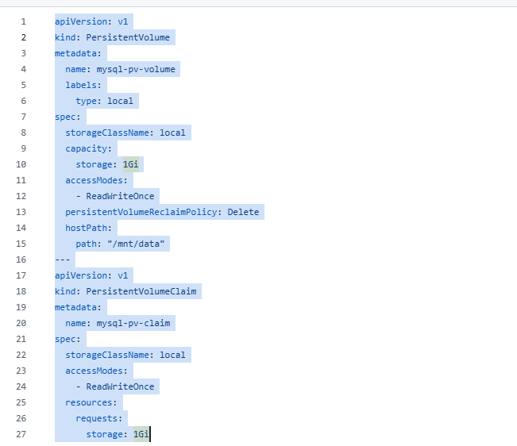
PersistentVolume

kind: PersistentVolume The reason we use kind: PersistentVolume (PV) in Kubernetes is to provide stable and lasting storage for applications running in the cluster. Unlike regular storage tied to a pod that disappears when the pod is deleted, a PV keeps data safe even if pods restart or get replaced.
labels:
type: local
Help match PersistentVolumes (PV) to PersistentVolumeClaims (PVC) using label selectors.
Enable filtering and grouping volumes for easier management.
Support automation and scheduling decisions based on volume characteristics.
storageClassName: "local"
Think of this as the "type" of storage. "local" means it uses storage directly on the same machine (node) where your app runs.
capacity: storage: 1Gi
This sets the size of the storage to 1 gigabyte (1Gi).
accessModes: ReadWriteOnce
This means only one node at a time can read from and write to this storage.
persistentVolumeReclaimPolicy: Delete
When you're done using this storage, it will be deleted automatically.
hostPath: path: "/mnt/data"
This points to the actual folder on the machine where the data is stored.
In simple terms, this config reserves a 1GB folder on the node’s disk at /mnt/data. Only one node can use it at a time, and it will be cleaned up when you release it. This setup is useful for apps like databases that need to save data persistently on a specific node.
---
PersistentVolumeClaim
kind: PersistentVolumeClaim
A PersistentVolumeClaim (PVC) in Kubernetes is a request made by a pod (application) asking for storage space. It specifies how much storage is needed, the type of storage, and access permissions. Kubernetes then finds or creates a matching PersistentVolume (PV) to fulfill this request.
For example, if your app needs 1Gi of local storage with read-write access, you create a PVC, and Kubernetes links it to a suitable PV so your app can use that storage safely and persistently.
storageClassName: local
Tells Kubernetes to use local storage tied to a specific node
It means the storage is on a physical disk or directory of a particular machine, not in the cloud or network. This storage is not created automatically; it must be set up manually and is fast but limited to one machine.
For example: So, instead of storageClassName: local, use the storage class name linked to EBS in your cluster. This instructs Kubernetes to provision and attach an EBS volume to your pod instead of local node storage.
storageClassName: ebs-sc

accessModes:
- ReadWriteOnce
The volume can be mounted as read-write by only one node at a time.
Multiple pods on the same node can share the volume with read-write access.
No other nodes can mount the volume simultaneously.
This mode is commonly used for block storage like EBS, local disks, or persistent disks where exclusive write access is required.
In simple terms, only one node can use the volume for both reading and writing at once, but multiple pods on that node can share it

Resources:
requests:
storage: 1Gi
The resources.requests.storage: 1Gi part in a PersistentVolumeClaim (PVC) specifies how much storage space the pod is requesting — in this case, 1 gigabyte.
It tells Kubernetes you need at least 1Gi of storage to be allocated.
Kubernetes will try to find a PersistentVolume (PV) that meets or exceeds this size.
If dynamic provisioning is enabled, Kubernetes will create a new volume of at least this size.
This ensures your application gets the required persistent storage capacity.
In simple terms, this line asks Kubernetes to reserve 1Gi of storage for the pod's use.

Kubectl apply –f pv.yml
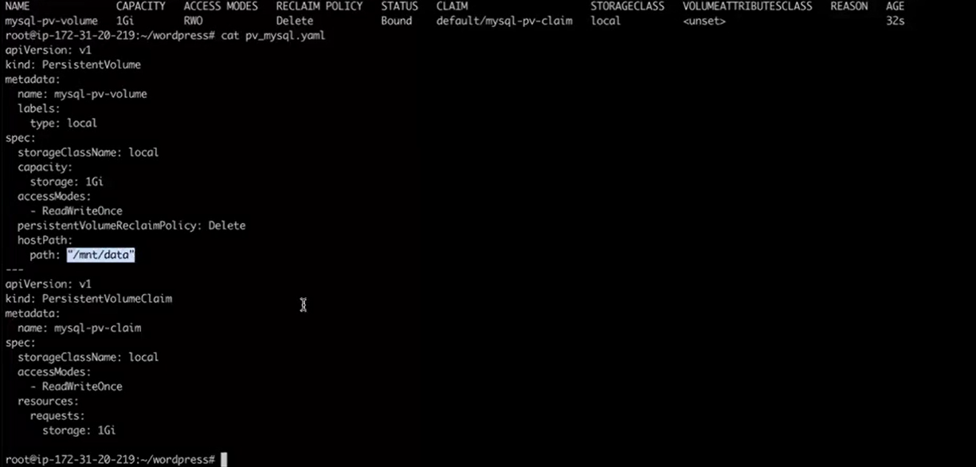
path: "/mnt/data"
directory or file on the physical node (host) where the pod is running, not inside the pod itself.
The main purpose of a host Path volume in Kubernetes is to let a pod access storage on the physical node where it runs by mounting a directory or file from that node into the pod’s filesystem. This means any data saved by the pod is actually stored on the host machine itself, allowing direct interaction with the node’s local storage.
When a pod uses a host Path volume, it essentially shares a specific directory from the Kubernetes node with the container inside the pod. This setup is mainly useful in development, testing, or when pods need access to specific host resources. However, because the storage is tied to a particular node, if the pod moves to another node, it loses access to that data.

Capacity = 1G means 1 GB storage.
Access Modes: RWO
The "ReadWriteOnce" (RWO) access mode in Kubernetes means a PersistentVolume can be mounted as read-write by only one node at a time. Multiple pods on that node can read and write the volume concurrently. However, pods on other nodes cannot mount it for write access simultaneously. This mode is common for applications needing exclusive write access, like databases, helping ensure data safety and consistency.
For comparison:
ReadOnlyMany (ROX): many nodes can mount the volume as read-only.
ReadWriteMany (RWX): many nodes can mount the volume as read-write at the same time.
In short, RWO restricts write access to a single node but allows multiple pods on that node to share the volume.

Reclaim Policy: Delete
The "Delete" reclaim policy in Kubernetes means that when you delete the PersistentVolumeClaim (PVC) that uses a PersistentVolume (PV), the underlying storage (e.g., disk) is automatically deleted too. This is useful for automatic cleanup of temporary storage, so you don't have to delete leftover volumes manually. However, if you want to keep the data after deleting the PVC, use the "Retain" policy instead, which keeps the storage for reuse or manual recovery.
In short:
Delete: Storage is removed with the PVC (good for temporary data)
Retain: Storage is kept after PVC deletion (good for important data)

Status: Bound (means the PV is successfully bound to a PersistentVolumeClaim)

StorageClass: local Kubernetes refers to using local storage on the node itself, such as a disk, partition, or directory physically attached to that node. Unlike cloud or networked storage that can be dynamically provisioned, local storage is static and tied to a specific node.

Mysql_deployment.yaml

Both service and mysql database pods are created.
As soon as we create the database (mysql ) pod . it will create default schema.

Only one data base we have created.
Let’s get into database pod
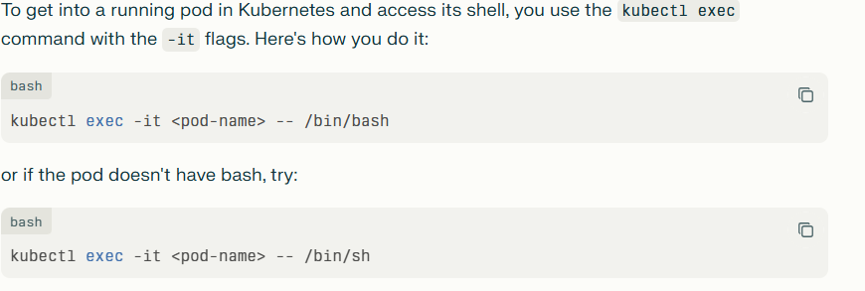

kubectl exec -it mysql-6c7cb74999-2j5v7 -- /bin/bash
as soon as we enter the pod
mysql -u root –p , password is password
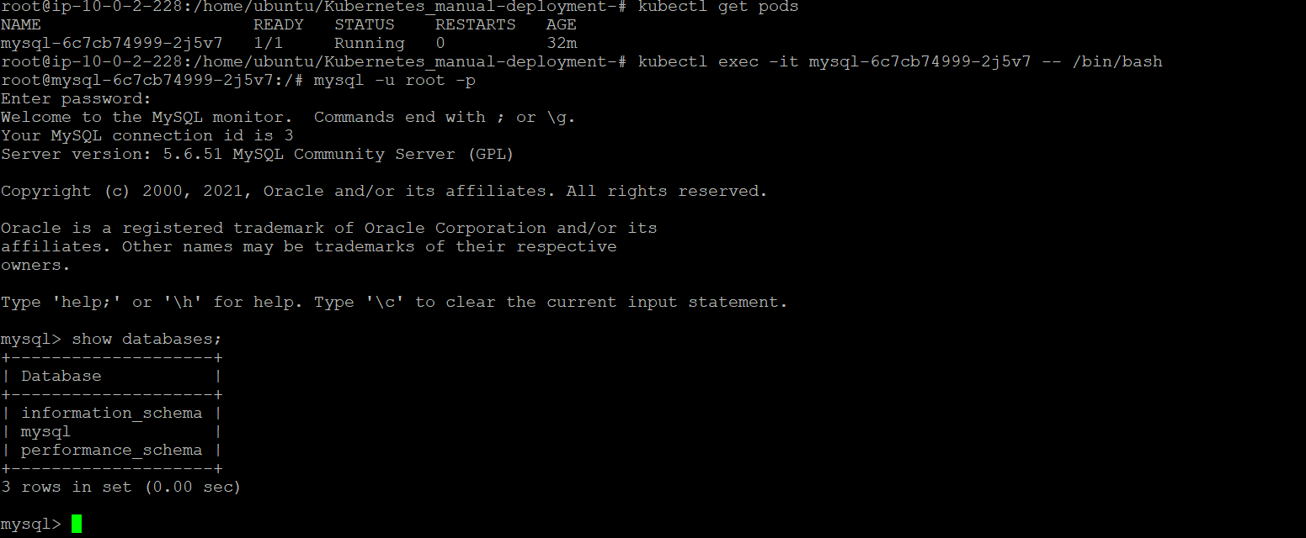
It will display the all default schemas.
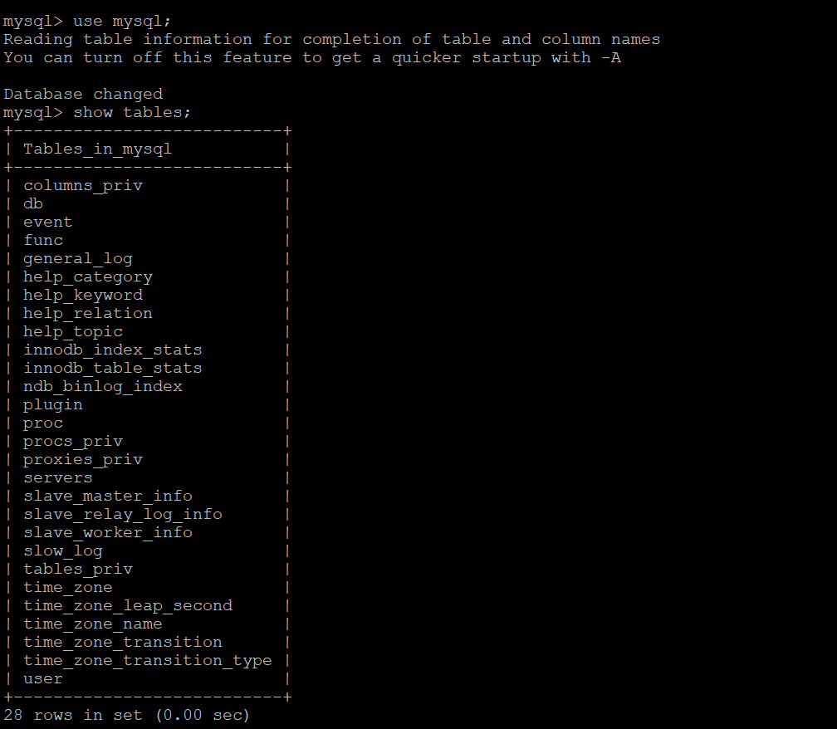
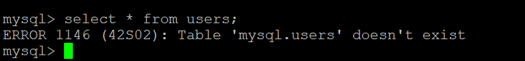
There is no user. Once we create the user, user information will be stored in user.

wordpress.yaml
This file contain both service (load balancer) and application code images.
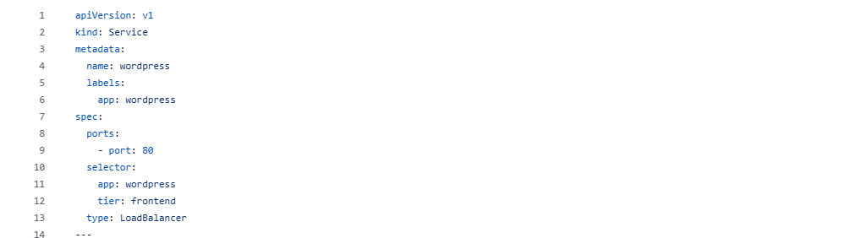

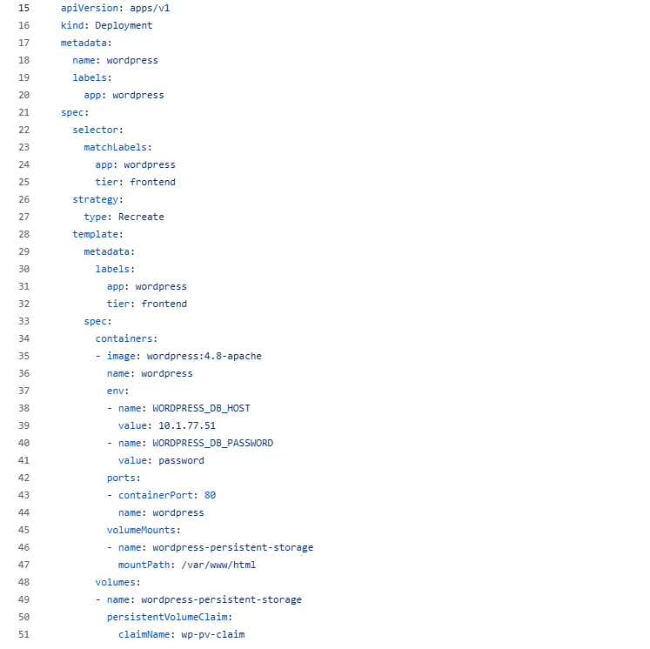

Take cluster ip of mysql
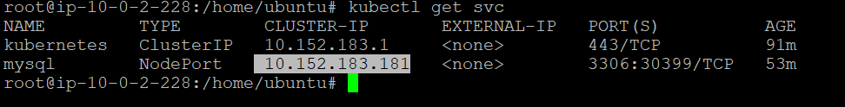

Take ip address and update wordpress.ymal file .it mean we connecting both database and application.
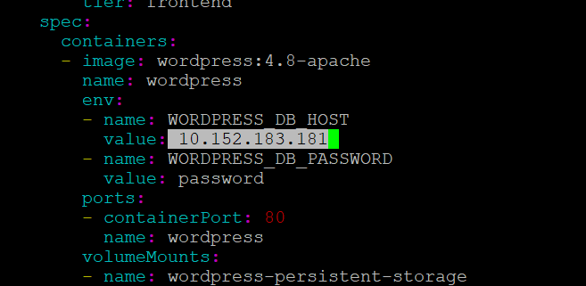
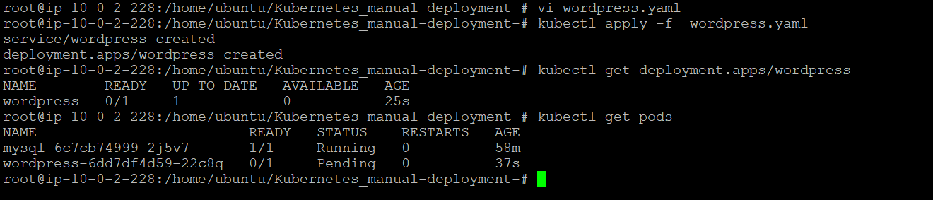

kubectl apply -f pv_wordpress.yaml
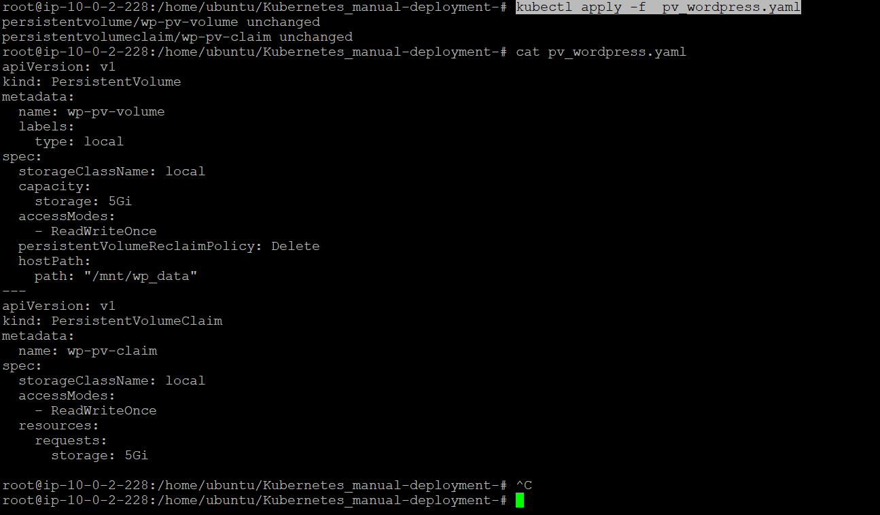

This pv and pvc for application pods

Application is lunched
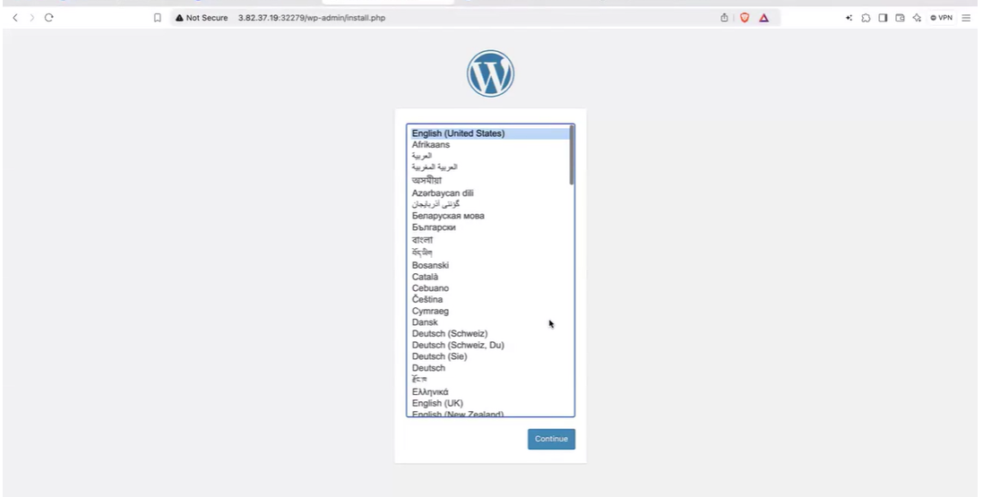

Application user login information is stored in database ( mysql-pod)

